RITA_Mega_UAT Issues :

Issue 1: Soft_deleted_flag (Fixed in PROD Dev instance)

Issue 2: Noticed ‘UNKNOWN’ in PROD UAT instance for below attribute :

Attribute : Number of 3rd party Users with Access.

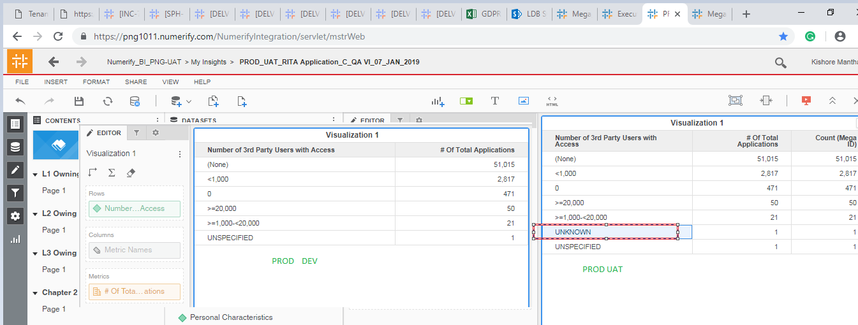

Volume of Records-For Data Stakeholders From All Countries

Volume of Records-For Data Stakeholders From EU

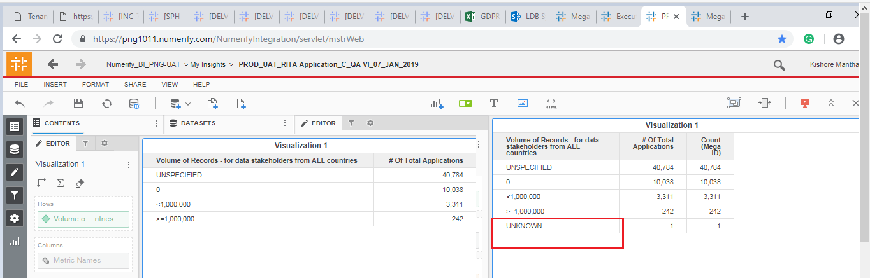

Issue 3: Only ‘N’ are populated in 'Protected Health Information (“PHI”) as defined by HIPAA' attributes.

SELECT (CASE WHEN SRC1.ATTRIBUTE_NAME ='Protected Health Information (“PHI”) as defined by HIPAA' THEN 'Y' ELSE 'N' END ),TRGT.phi_flag,

Count(distinct SRC.Name) as CNT

FROM png_mdsdb.pg_mega_pgb_application_rita_final SRC

LEFT JOIN png_mdsdb.pg_mega_pgv_application_data_model_final SRC1 ON SRC.NAME=SRC1.APP_HEX AND SRC.sourceinstance=SRC1.sourceinstance

LEFT JOIN png_mdwdb.d_rita_application_c TRGT ON SRC.NAME=TRGT.row_id AND SRC.sourceinstance=TRGT.source_id

WHERE SRC.cdctype<>'D'

group by 1,2

